Business Intelligence Security & Data Protection Report
Experiment 9: Authentication, Authorization, RBAC & Row-Level Security
Course / Lab: Business Intelligence & Analytics — Experiment 9 | Dataset: Global Superstore Dataset (51,290 Records)
Security Architecture: Microsoft Power BI Desktop / Service, Azure AD, DAX RLS | Focus Deliverable: Access Control Matrix, RLS Design & Risk Assessment

1. Aim & Objectives
To understand and implement enterprise Business Intelligence security architectures—including multi-factor authentication, role-based access control (RBAC), Row-Level Security (RLS), and data exfiltration defense—using Microsoft Power BI Desktop and Service. The objective is to protect sensitive corporate assets, ensure regulatory compliance, and enforce the principle of least privilege across global operations.
- Identify information requirements across diverse organizational roles (CEO, Sales Manager, Finance Manager, Regional Manager).
- Compare enterprise authentication approaches (Username/Password vs. Azure AD vs. Multi-Factor Authentication).
- Design a granular Role-Based Access Control (RBAC) permission matrix balancing view, edit, share, and administrative rights.
- Engineer a Row-Level Security (RLS) strategy using DAX expressions to partition regional order transactions automatically.
- Conduct a comprehensive security risk assessment and formulate an executive mitigation roadmap.
2. Supporting BI Dashboard Architecture
The security strategy governs the operational dashboard established in prior experiments, encompassing 51,290 transactions across 13 global regions with $12,642,501.91 in Total Sales, $1,467,457.29 in Total Profit, and 25,728 distinct orders. Figure 9.1 depicts the central dashboard interface whose regional, category, and customer dimensions must be protected through role-based governance.
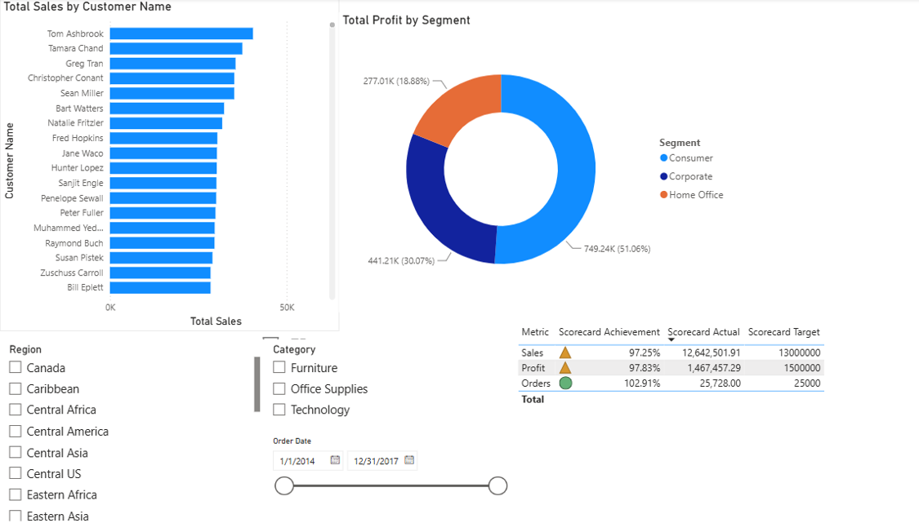
Figure 9.1: Global Superstore Executive Performance Dashboard Governed by BI Security
3. User and Role Identification (Part A)
Security governance begins with mapping organizational roles to their legitimate operational data requirements. Enforcing the principle of least privilege ensures users receive only the information necessary to fulfill their responsibilities. Table 9.1 delineates the role and information matrix designed for Global Superstore.
User Role | Required Reports / Dashboards | Data Scope / Granularity | Access Requirement & Purpose
Chief Executive Officer (CEO) | Executive Dashboard, Global KPI Scorecard, Strategic Trends | Global Aggregated (All Regions, Categories, Multi-Year) | Read-only strategic oversight; monitor target quotas and overall company growth.
Global Sales Manager | Sales Performance by Region, Top 10 Customers, Segment Performance | Global Operational & Customer Detail (Transaction Level) | Read & analytical filtering; evaluate sales representative pipeline and key accounts.
Global Finance Manager | Profit by Category, Cost & Margin Analysis, Scorecard Financials | Global Financial & Margin Detail (Costs, Discounts, Profits) | Read & analytical drill-down; monitor margin leakage, discount thresholds, and net profits.
Regional Sales Manager (e.g., Western Europe) | Regional Sales & Profit, Regional Territory Slicers, Branch Scorecard | Restricted to Assigned Region Only (Filtered via RLS) | Operational tracking of local branch performance without exposure to competitor territory data.
BI Report Author / Developer | All PBIX Reports, Data Models, DAX Measures, Power Query Pipelines | Full Data Model Schema & Raw Underlying Datasets | Create, modify, test, and publish reports and semantic models across workspaces.
BI Workspace Administrator | Power BI Admin Portal, Workspace Settings, Access Control, Audit Logs | Entire Workspace Environment & Security Metadata | User provisioning, security role assignment, dataset gateway configuration, and audit compliance.

4. Authentication Analysis & Identity Verification (Part B)
Authentication validates the verified identity of a user prior to granting entry to the BI tenant. In Microsoft Power BI Service, identity verification is managed through Microsoft Entra ID (formerly Azure Active Directory). Table 9.2 evaluates three distinct authentication methods across usability, enterprise scalability, and security posture.
Authentication Method | Implementation Mechanism | Key Benefits / Advantages | Security Considerations & Risks
Basic Username / Password | Local database or basic credential store prompting for username and password string. | Simple to configure for legacy standalone tools; minimal infrastructure requirements. | Extremely vulnerable to brute-force attacks, credential stuffing, phishing, and lack of centralized password lifecycle policies.
Organizational Account (Azure AD / Entra ID) | Centralized corporate Single Sign-On (SSO) using federated identity (SAML, OAuth 2.0). | Seamless access across Microsoft 365 / Power BI; instant account de-provisioning on termination; centralized governance. | Requires cloud directory infrastructure; single point of compromise if identity layer is breached without additional verification layers.
Multi-Factor Authentication (MFA) | Requires 2+ independent verification factors (Password + Authenticator App / FIDO2 Token / SMS). | Eliminates >99.9% of credential-based attacks; ensures compliance with ISO 27001 / SOC 2; protects sensitive financial BI. | Minor user friction during sign-in; requires fallback enrollment for device loss; slightly higher initial setup complexity.

Advantages of Multi-Factor Authentication (MFA) in BI Environments
Modern BI systems contain aggregated financial data, pricing contracts, and confidential customer lists. Mandating MFA prevents credential stuffing, session hijacking, and brute-force penetration by requiring a second physical or cryptographic token (e.g., Microsoft Authenticator app push or FIDO2 hardware key). This reduces unauthorized access risk by over 99%.
5. Authorization & Access Control Design (Part C)
Authorization determines what an authenticated user is permitted to do. Power BI Service provides four core workspace roles: Admin, Member, Contributor, and Viewer. Table 9.3 maps organizational roles to these security permissions, strictly enforcing least privilege.
User Role | View | Edit | Share | Admin | PBI Workspace Role | Governance Justification
CEO / C-Suite | Yes | No | No | No | Viewer | Requires strategic decision consumption only; editing risks accidental formula changes; sharing restricted to maintain confidentiality.
Sales Manager | Yes | No | Yes | No | Contributor | Needs viewing and sharing with regional teams; no administrative rights over datasets to preserve governance.
Finance Manager | Yes | No | Yes | No | Contributor | Requires deep analytical access and report sharing with financial audit leads; cannot edit underlying data models.
Regional Sales Manager | Yes | No | No | No | Viewer (RLS Filtered) | Strictly limited to view assigned regional data; cannot re-share externally or view cross-region financials.
BI Report Author | Yes | Yes | Yes | No | Member | Requires authoring and visual layout creation; permitted to publish and share with testing cohorts; no workspace deletion rights.
BI Workspace Admin | Yes | Yes | Yes | Yes | Admin | Responsible for workspace lifecycle, gateway connectivity, user role provisioning, and audit oversight.

6. Row-Level Security (RLS) Planning & DAX Design (Part D)
Row-Level Security (RLS) restricts data access at the row level based on the identity of the current user. In Global Superstore, while executive leaders require consolidated global visibility, regional managers must only view records pertaining to their territories. Figure 9.2 demonstrates the geographic revenue distribution whose branches are isolated using DAX security filters.
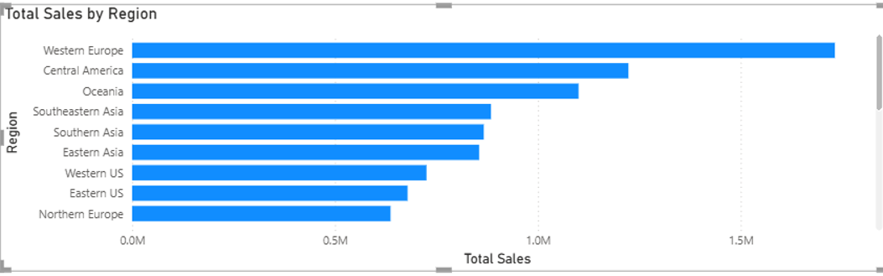
Figure 9.2: Regional Sales Distribution Partitioned via Row-Level Security Rules
Security Role Name | Target Table | DAX Filter Expression | Permitted Data Scope | Operational Purpose
Western_Europe_Manager | Orders | [Region] = "Western Europe" | Western Europe orders only ($1.73M sales baseline) | Isolates top-performing European territory; shields customer records and pricing from external territories.
Central_America_Manager | Orders | [Region] = "Central America" | Central America orders only ($1.22M sales baseline) | Confines manager visibility to Latin American operations and accounts.
Oceania_Manager | Orders | [Region] = "Oceania" | Oceania orders only ($1.10M sales baseline) | Restricts Pacific territory data to regional operations.
North_America_Manager | Orders | [Region] IN {"Western US", "Eastern US", "Central US", "Southern US", "Canada"} | All North American territories combined | Aggregates US and Canadian sub-regions under regional vice presidency while excluding EMEA/APAC.
Global_Executive_Role | Orders | 1 = 1 (No Filter) | All 51,290 transactions across all 13 global regions | Enables CEO, CFO, and Global Sales VP to access corporate consolidated reports without regional barriers.

Technical Steps to Implement RLS in Power BI Desktop & Service
- Step 1 (Create Roles): Open Report in Power BI Desktop: Navigate to Modeling tab > Manage roles.
- Step 2 (Define Expression): Create Role & Enter DAX Filter: Click Create. Name the role Western_Europe_Manager. Under Tables, select Orders, and in the Table filter DAX expression box, enter: [Region] = "Western Europe". Click Save.
- Step 3 (Verify via 'View as'): Test Roles Locally: In the Modeling ribbon, click View as. Select Western_Europe_Manager and click OK. Verify that all charts (Sales by Region, Top Customers, KPI Cards) automatically recalculate to reflect only Western Europe data ($1.73M sales).
- Step 4 (Service Mapping): Publish & Assign Cloud Users: Save and publish the report to Power BI Service. In the workspace, locate the dataset, click More options (...) > Security. Under the Western_Europe_Manager role, add the email addresses or security groups of European managers and click Save.
7. Security Risk Assessment & Mitigation Measures (Part E)
Deploying business intelligence solutions introduces distinct attack vectors. Table 9.5 documents the security risk assessment conducted across identity, authorization, and data exfiltration vectors, establishing enforceable mitigation controls.
Identified Threat / Risk | Category | Severity | Recommended Security Control | Monitoring Mechanism
Unauthorized Data Access via Credential Theft | Authentication | High | Enforce Azure AD Multi-Factor Authentication (MFA) and Conditional Access policies for all Power BI accounts. | Azure AD Sign-in Logs & Identity Protection alerts.
Excessive Permissions (Privilege Creep) | Authorization | High | Apply Role-Based Access Control (RBAC); assign 'Viewer' by default; conduct quarterly access certification audits. | Power BI Admin Workspace Access Review quarterly.
Cross-Regional Data Leakage | Data Protection | Critical | Implement DAX-based Row-Level Security (RLS); test roles using 'View as' in Desktop prior to cloud publishing. | Service RLS mapping verification & row-count checks.
Accidental Sharing / Data Exfiltration | Data Governance | Medium | Disable 'Allow users to share reports' in Viewer roles; enforce Microsoft Information Protection (MIP) sensitivity labels. | Power BI Activity Log & Microsoft Purview audit.
Unencrypted Local PBIX Distribution | Endpoint Security | High | Mandate that production PBIX files are saved only to encrypted corporate OneDrive / SharePoint; prohibit local unmanaged copies. | Endpoint DLP policies and local disk BitLocker encryption.

8. Conclusion & Deliverables Summary
Experiment 9 establishes a robust, defense-in-depth security framework for enterprise Business Intelligence. By integrating Azure AD Multi-Factor Authentication, strict Role-Based Access Control workspace roles (Admin, Member, Contributor, Viewer), and granular DAX Row-Level Security, Global Superstore ensures that confidential financial metrics, customer transaction details, and strategic scorecards remain fully protected against unauthorized exposure while empowering stakeholders with precisely the data they need.

